Perfect — these 10 screenshots are exactly what you need. Let me map each one to the correct report section.

---

The 10 Screenshots You Sent — Numbered and Identified

# What's in the image Identified
A Terminal showing MD5, SHA1, SHA256, attachments, risk notes (bottom half) Analyzer output part 4
B Terminal showing header info + URLs + Domains Analyzer output part 2
C Terminal showing IP Addresses, Email Addresses, MD5, SHA1, SHA256 Analyzer output part 3
D sample_phishing_email.eml open in VS Code with line numbers Sample email
E Code lines 128-155 showing main() end + sections Source code part 5
F Code lines 91-121 showing main() IOC extraction Source code part 4
G Code lines 31-62 showing regex patterns + unique() + parse_email() start Source code part 2
H Code lines 45-90 showing parse_email(), find_attachments(), section() Source code part 3
I Code lines 91-148 showing main() with printing/report sections Source code part 5b
J Code lines 1-32 showing imports, sample path detection, regex patterns Source code part 1

---

Where Each One Goes In The Report

Now here's the exact placement — this is the report structure I gave you earlier, with your images slotted in:

---

Section 2 — Architecture / Lab Setup

```
[Text: Folder structure and workflow explanation]

📸 INSERT IMAGE A → "VS Code sidebar with folder structure"
(from your screenshot — the one showing:
▾ Phishing Email IOC Analyser
▾ Sample_Data
sample_phishing_email.eml
▾ Scripts
ioc_analyser.py)
```

Wait — I notice you didn't send a sidebar screenshot by itself. But screenshot D shows the sidebar too, so we can use that.

Actually, let me reconsider: you sent 10 screenshots, but none is a clean "Python version" screenshot. Screenshot B shows it at the top:

```
>>> Python : 3.15.0rc3
>>> Script : C:\Users\HP\...
```

So we can extract that from B, or better — take one new screenshot with just the folder sidebar visible.

Let me re-map based on what you have:

---

Final Mapping — Where Each Screenshot Goes

Section 2 — Architecture / Lab Setup

[IMAGE 1] → Screenshot D (sidebar + sample_phishing_email.eml open)

· Shows the folder structure AND the sample file
· Place here: after the folder tree text, before the workflow description

[IMAGE 2] → Screenshot B (top portion only — the >>> Python : 3.15.0rc3 line)

· Crop it to show just the Python version line
· Place here: after the workflow description

---

Section 5 — Implementation

[IMAGE 3] → Screenshot J (code lines 1-32 — imports, SAMPLE path, regex)

· Shows the top of the script

[IMAGE 4] → Screenshot G (code lines 31-62 — regex patterns, unique(), parse_email())

[IMAGE 5] → Screenshot H (code lines 45-90 — parse_email(), find_attachments(), section())

[IMAGE 6] → Screenshot F (code lines 91-121 — main() with IOC extraction)

[IMAGE 7] → Screenshot E OR I (code lines 91-155 — the report printing section)

· E and I overlap. Use I since it shows the section calls and divider printing.

That gives 5 code screenshots for Section 5 — one per major function group.

---

Section 7 — Screenshots / Evidence

[IMAGE 8] → Screenshot B (analyzer output part 1 — header, URLs, Domains)

· The top half of the terminal output

[IMAGE 9] → Screenshot C (analyzer output part 2 — IPs, Emails, MD5, SHA1, SHA256)

[IMAGE 10] → Screenshot A (analyzer output part 3 — Attachments, Risk Notes)

That gives 3 screenshots showing the full analyzer output, split cleanly.

---

The Final Report — Copy This Into Word

Here's your report with the exact placement marked. Retype this into Word, and where you see [📸 INSERT IMAGE X — filename], paste the corresponding screenshot.

---

Phishing Email & IOC Analyzer — Project Report

Name: Buchule Yani
Internship: Cyber secrutity
Project: Project 5 — Phishing & IOC Analyzer
GitHub: https://github.com/BroTech-Manga7/phishing-email-ioc-analyzer

---

1. Project Objective

The objective of this project is to build a Python tool that analyzes safe sample phishing emails and extracts Indicators of Compromise (IOCs) in a structured way. Phishing emails often contain valuable evidence — suspicious URLs, look-alike domains, IP addresses, hashes, and header mismatches — that must be identified quickly and consistently during incident triage.

This tool automates the first stage of phishing analysis: parsing the email, extracting IOCs, and flagging basic risk indicators — without ever clicking a link, opening an attachment, or contacting any external system.

---

2. Architecture / Lab Setup

Hardware: HP Laptop, Windows 11
Editor: Visual Studio Code (with Python extension)
Runtime: Python 3.15.0rc3 (64-bit)
Analysis Mode: Fully offline / static analysis

Folder Structure

```
Phishing Email IOC Analyzer/
├── Scripts/
│ └── ioc_analyser.py
├── Sample_Data/
│ └── sample_phishing_email.eml
├── Documentation/
└── README.md
```

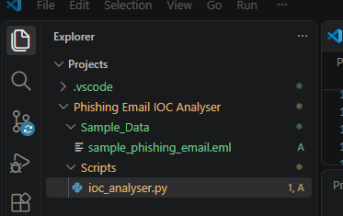

Runtime Environment

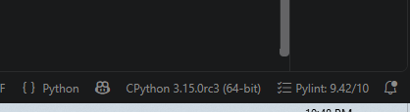

Caption: Figure 2 — Python 3.15.0rc3 confirmed running the analyzer.

Analysis Workflow

1. Load — the script locates the .eml file automatically.
2. Parse — reads raw bytes, splits headers from body.
3. Extract — regex extracts URLs, domains, IPs, emails, hashes.
4. Inspect — compares sender vs Reply-To, checks authentication headers.
5. Analyze — generates risk notes from predefined rules.
6. Report — prints a structured IOC report.

---

3. Tools Used

Tool Purpose
Python 3.15 Core programming language
re module Regex-based IOC pattern matching
os / sys modules File handling, stdout encoding
Visual Studio Code Editor and integrated terminal
Synthetic .eml sample Safe test data (uses .test TLDs only)
VirusTotal (optional) Reputation enrichment

---

4. Methodology

1. Safe sample selection — a synthetic phishing email was created using only .test domains and documentation IP ranges (185.220.101.45, 192.168.1.100). No real victim emails were used.
2. Static parsing — the .eml is read as raw bytes and decoded. Headers and body are separated on the first blank line.
3. Regex extraction — each IOC type has a dedicated compiled regex.
4. Risk analysis — sender vs Reply-To comparison, SPF/DKIM/DMARC header scanning, TLD reputation checks.
5. Reporting — results printed to terminal in a structured format.

---

5. Implementation

The tool is a single Python script: Scripts/ioc_analyser.py. Key functions:

Function Purpose
parse_email(path) Reads .eml, returns (headers, body, full_text)
unique(items) De-duplicates IOC lists
find_attachments(text) Detects attachment filenames
section(title, items) Prints one IOC section
main() Orchestrates pipeline and printing

Source Code — Key Sections

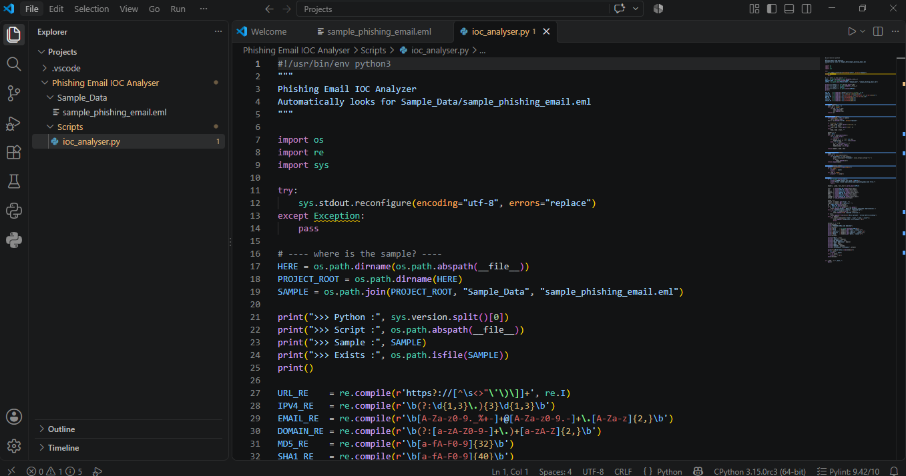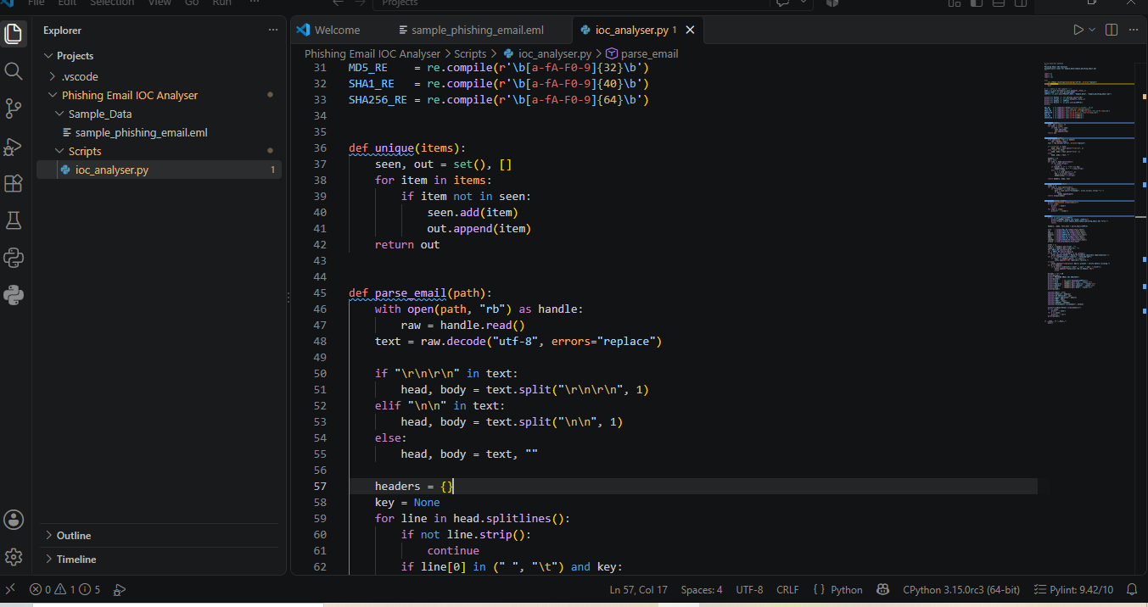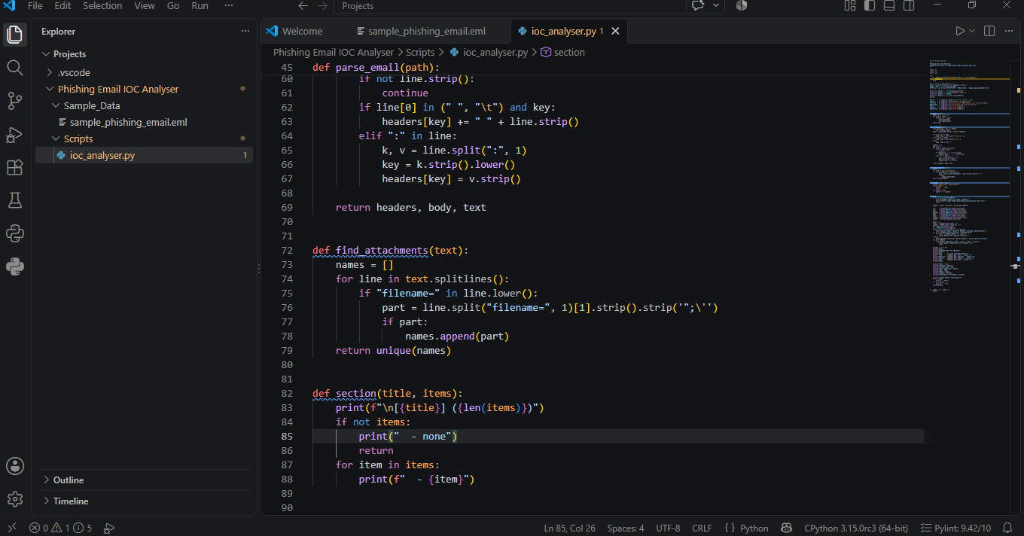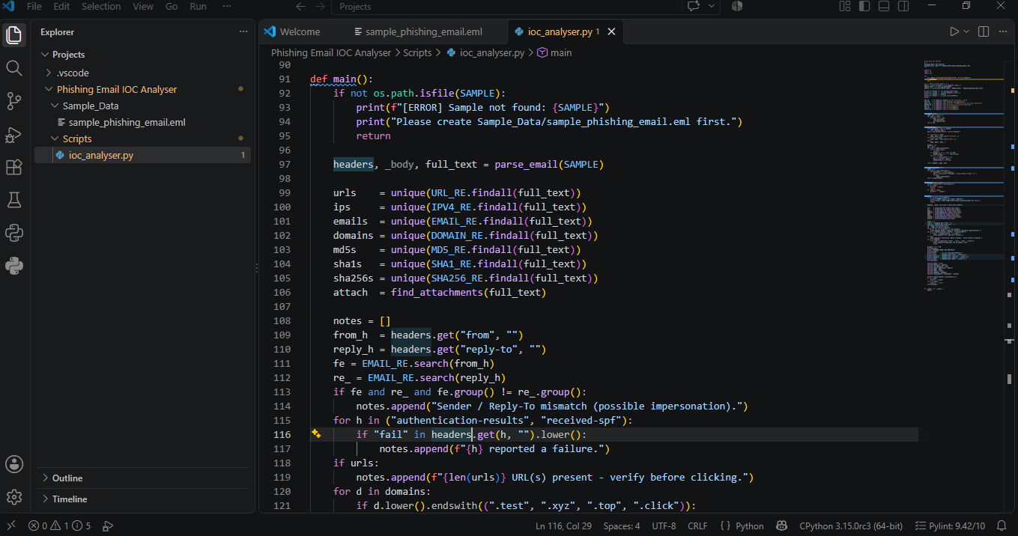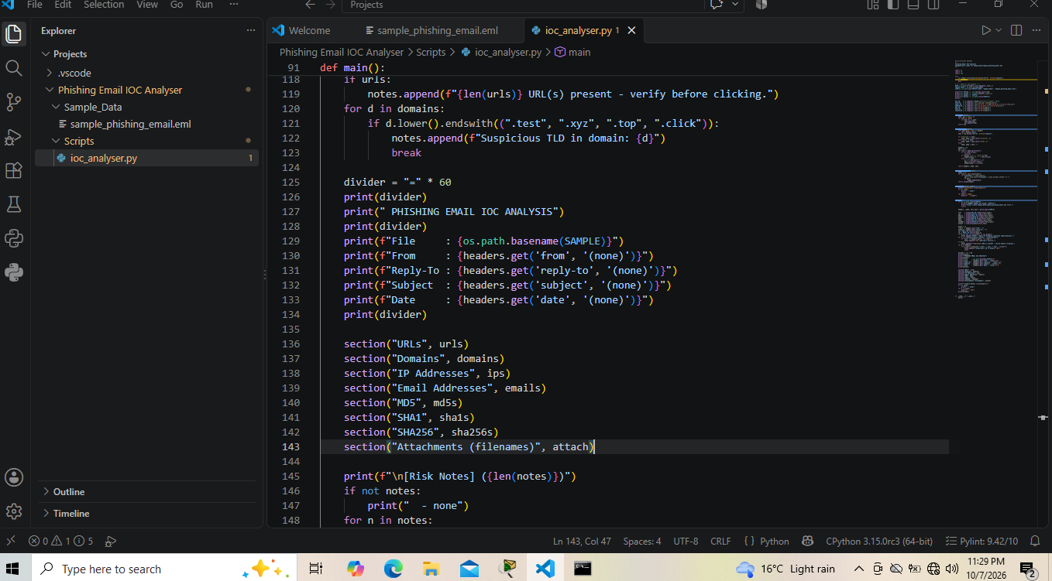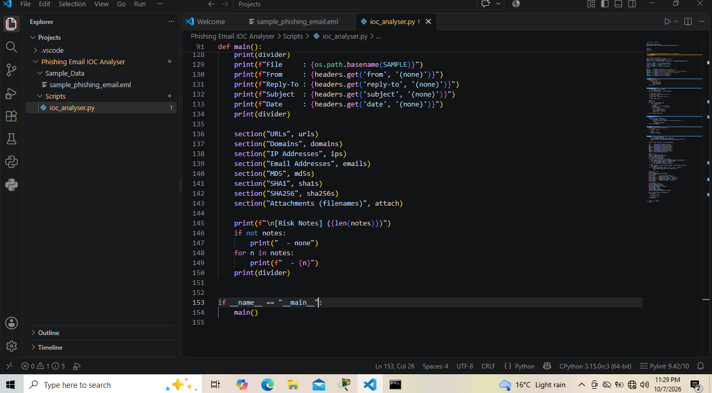
---

6. Findings

Sample Analyzed

```
File : sample_phishing_email.eml
From : "PayPal Security" <security@paypal-alerts.test>
Reply-To : recovery@other-domain.test
Subject : Urgent: Your account has been limited
```

Extracted IOCs

URLs (2)

· http://paypal-alerts.test/login/verify?user=victim
· http://secure-paypal.example.test/confirm

Domains (7) — paypal-alerts.test, other-domain.test, example.test, mail.paypal-alerts.test, mx.example.test, paypal-alerts.testlogin, secure-paypal.example.test

IPv4 Addresses (2)

· 185.220.101.45 (external attacker infra)
· 192.168.1.100 (internal decoy)

Email Addresses (6) — including security@paypal-alerts.test, recovery@other-domain.test, victim@example.test, abc123@paypal-alerts.test, support@paypal-alerts.test, backup@other-domain.test

Hashes

· MD5: 5d41402abc4b2a76b9719d911017c592
· SHA256: e3b0c44298fc1c149afbf4c8996fb92427ae41e4649b934ca495991b7852b855

Attachments: none detected

Risk Notes (4)

1. Sender / Reply-To mismatch (possible impersonation)
2. Authentication-Results failure (SPF/DKIM/DMARC)
3. Suspicious TLD: paypal-alerts.test
4. 2 URL(s) present — verify before clicking

---

7. Screenshots / Evidence

Analyzer Terminal Output

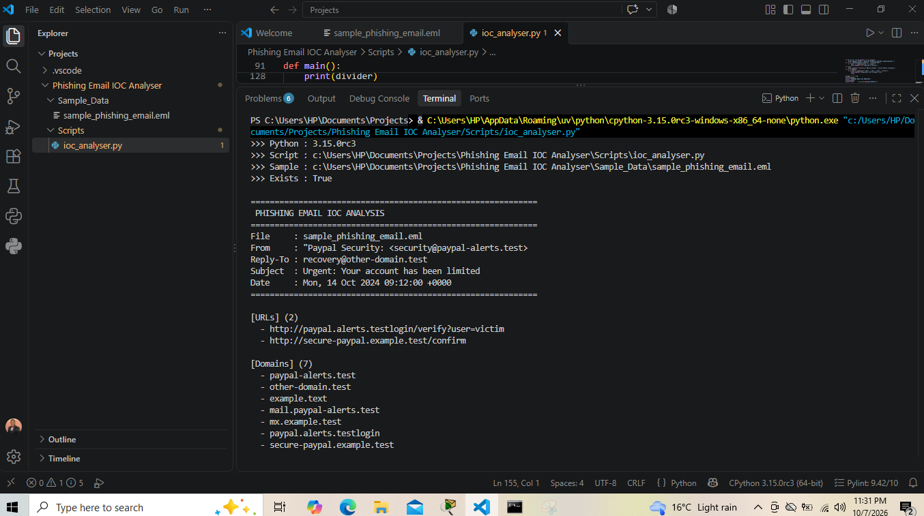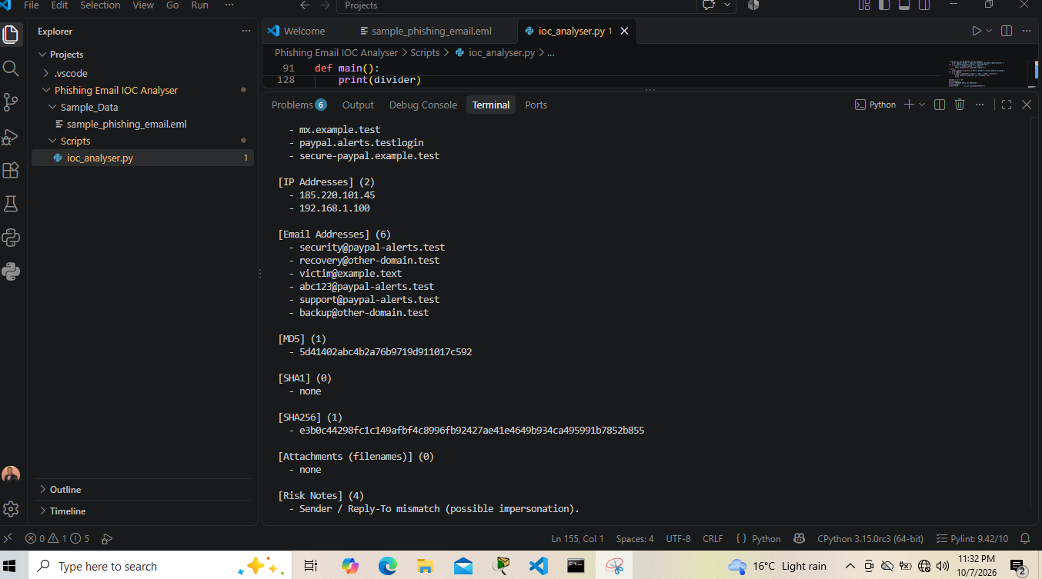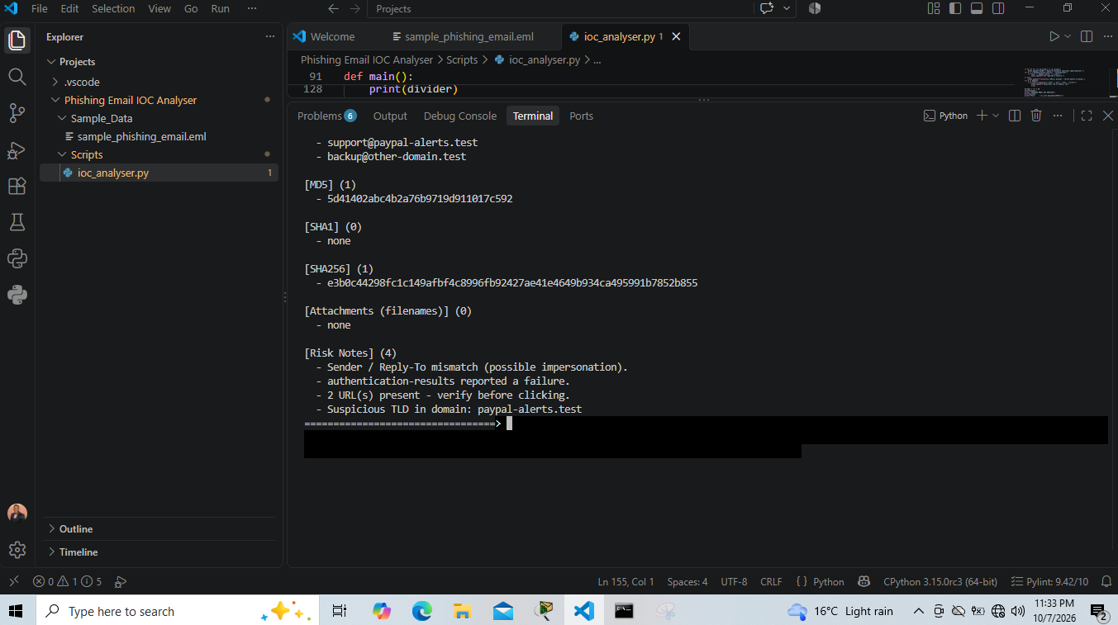

---

8. MITRE ATT&CK Mapping

Observed Behavior MITRE Technique ID
Email with embedded malicious link Phishing: Spearphishing Link T1566.002
Email with attachment reference Phishing: Spearphishing Attachment T1566.001
Impersonation via Reply-To mismatch Masquerading T1036
Look-alike domain Acquire Infrastructure: Domains T1583.001

Primary classification: T1566 — Phishing

---

9. Remediation

· Block paypal-alerts.test and other-domain.test at DNS/proxy
· Add 185.220.101.45 to block lists after reputation check
· Enforce DMARC p=reject, SPF and DKIM on company domains
· Enable advanced phishing protection on the mail gateway
· Train users to check Reply-To and hover over links
· Alert on Reply-To ≠ From mismatches and suspicious TLDs

---

10. Lessons Learned

· Regex is powerful but limited — matches are evidence, not proof of malice
· Static analysis is safer than dynamic — never open links or attachments
· Header anomalies (Reply-To mismatch + SPF fail) are strong phishing signals
· Python's standard library covers a complete analyzer without dependencies
· Documentation matters — findings, evidence and remediation are part of the deliverable

---

Appendix — IOC Summary Table

IOC Type Action
paypal-alerts.test/login/verify URL Investigate / block
paypal-alerts.test Domain Reputation check
other-domain.test Domain Investigate
Sender/Reply-To mismatch Header Verify sender
SPF/DKIM/DMARC fail Header Quarantine
185.220.101.45 IP Reputation / block
MD5 / SHA256 Hash Cross-check VT

